Setting up Licenses for GENESYS 2010.05 using the EEsof License Wizard
- Intended Audience
The purpose of this document is to illustrate in detail how to install the EEsof License Tools and then use the License Wizard included in the toolset to set up and configure a local license server to manage your license file to run your GENESYS 2010.05 software. This document is written for users unfamiliar with Agilent-EEsof licensing and have little or no experience performing Microsoft Windows IT tasks.

This document should be referenced for users who meet the following criteria:
- There is currently no Agilent-EEsof 2011 software applications installed on the machine. (For example: 2011 versions of ADS, SystemVue, GENESYS, EMPro, or ICCAP are not currently installed).
- Have received a counted nodelocked or counted floating license file from Agilent-EEsof Business Support.
- You have a v3.0 license file.

Note: These instructions require that your windows account is in the administrators group of the machine. If not, refer to this Knowledge Center article,
http://edocs.soco.agilent.com/display/eesofkcads/Administrator+Login+required+when+attempting+to+run+Agilent-EEsof+product

- Rename License File

- It is a best practice to rename your license file. Your license file is likely named in the format of ABCDEFG_abcdefg.lic. It is suggested to rename the license to <Product><LicenseFileVersion>.lic. For example, for these instructions, GENESYS30.lic is recommended.

- Download EEsof License Tools
- Download the EEsof License Tools Installation executable for Windows, eelic_install_win32_32_2012.08.exe. It can be acquired here,

www.agilent.com/find/eesof-flexnet-downloads

- Install EEsof License Tools
- Go to the folder containing your EEsof License Tools download.
- Right click on the installation executable and select “Run as Administrator”,
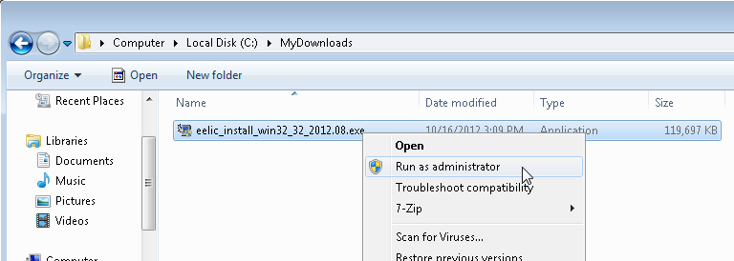
Fig. 1. Illustration: Right click on installation executable to “Run as administrator”

- Once launched, follow the installation wizard to perform the installation. During the installation process, an install location is provided that is user configurable. The following paths are recommended and may already appear by default

64 Bit systems: C:\Program Files (x86)\Agilent\EEsof_License_Tools
32 Bit Systems: C:\Program Files\Agilent\EEsof_License_Tools
Be certain to take note of the path you use, either the applicable one suggested above or your own custom path. You will need this for the next step.

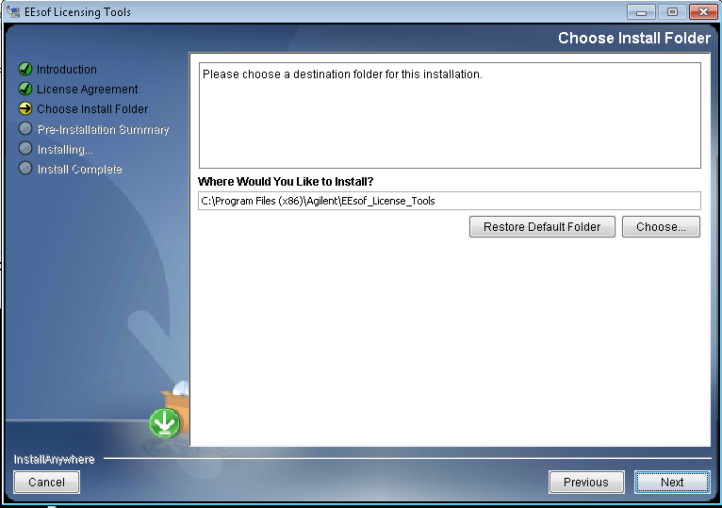
Fig. 2. EEsof License Tools installation wizard with default install location prompt for a 64 bit system.

With the installation path entered in the wizard, press Next to continue with the installation to ultimately launch the installer and finish. The installation is time is brief.

- Run the License wizard to configure License Server

- In the file system, navigate to the bin subfolder in the installation location that was chosen in the last step of the previous section. For example, if you used C:\Program Files (x86)\Agilent\EEsof_License_Tools as your installation folder, you would navigate to C:\Program Files (x86)\Agilent\EEsof_License_Tools\bin.

- Find the file aglmwizard.exe. Right click on it and “Run as administrator” to launch the License Wizard,
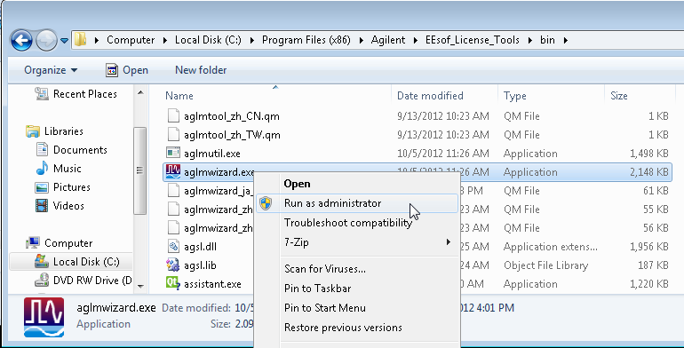
Fig. 3. Right click on the aglmwizard.exe to “Run as administrator” to run License Wizard.

- Once the License Wizard runs, you must select the program that is to be licensed.
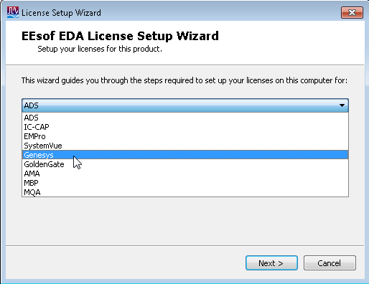
Fig 4. License Wizard drop down selection for client software that is being setup for licensing.

Select Genesys and press next.

- The wizard will now prompt you for what you want to do. Depending upon your current license environment, you should select one of the following options that appear:

“I want to use a different license file”
Or
“I have a license file to install”
Or
“I want to add or replace an existing license file”

Options explained:
“I want to use a different license file” is usually seen when an earlier version license file is installed
“I have a license file to install” is usually seen when a brand new license file is setup (and no previous version license is detected)
“I want to add or replace an existing license file” is usually seen when a license file for your Agilent EEsof application is installed and you are adding or removing licensed features

- Enter the path and name of the v3.0 license file you wish to install. Use the Add… Clear buttons to help you specify the location on your local hard disk where the license file was deposited and press Next,

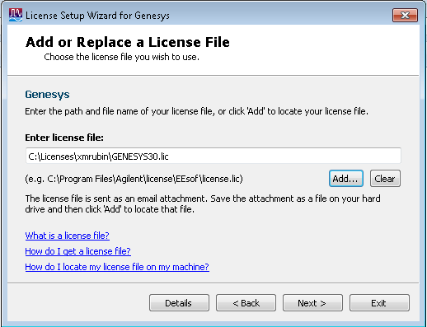
Fig. 5. Entering path to your local license file on your machine. Path above is an example.

- After step 5, the license wizard should complete with the following message. Press Exit,
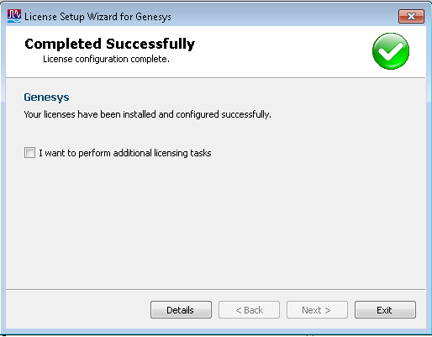
Fig. 6. Completion of License Wizard setup.

- Configuring the GENESYS client

- In the file system, navigate to the applicable folder,

64 bit systems: C:\Program Files (x86)\GENESYS2010.05\License
32 bit systems: C:\Program Files\GENESYS2010.05\license

Remove or save to a different folder any .lic files.

- Launch GENEESYS 2010.05. If GENESYS 2010.05 starts, you have completed the license setup.
- If GENESYS2010.05 does not launch, the GENESYS license authorization window will appear,

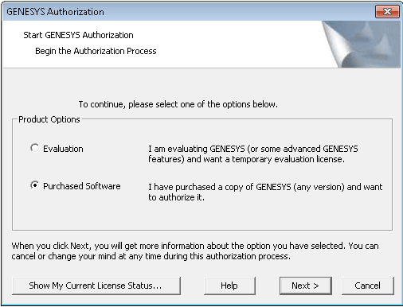
Fig. 7. GENESYS license authorization window. Select Purchased Software as shown.

Select Purchase software and press Next.

- You will now be prompted for Current License Path and Current Bundle Selection.

For Current License Path, select Change Path and enter @<local machine name>. For example, in Fig. 8 below, the local machine is xmrubin so the License Path is entered as @xmrubin

For Current Bundle Selection, select Change Bundle and move a bundle to right side “Selected License Bundles” area. Be careful to ensure that any “grayed out” bundles that appear on the right side of the bundle selector be removed.

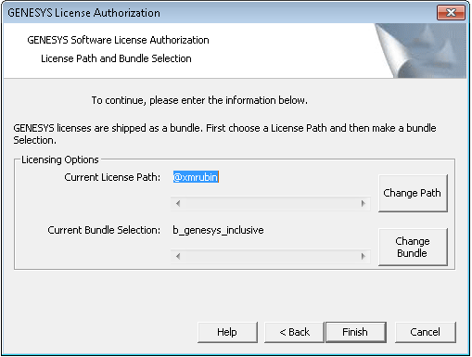
Fig. 8. Current License Path specified with @<local-machine-name> and license bundle selected.

Press Finish when done.

Upon completing above steps, GENESYS 2010.05 should now run.

