Setting up Licenses for GENESYS 2010.05 using the EEsof License Wizard – Quick Guide
- Intended Audience
The purpose of this document is to provide instructions to install the EEsof License Tools and then use the License Wizard included in the toolset to set up and configure a local license server to manage your license file to run your GENESYS 2010.05 software. This document is written for users familiar with Agilent-EEsof licensing and are comfortable with performing Microsoft Windows IT tasks.
This document should be referenced for users who meet the following criteria:
- There is currently no Agilent-EEsof 2011 software applications installed on the machine. (For example: 2011 versions of ADS, SystemVue, GENESYS, EMPro, or ICCAP are not currently installed).
- Have received a counted nodelocked or counted floating license file from Agilent-EEsof Business Support.
- You have a v3.0 license file.
Note: These instructions require that your windows account is in the administrators group of the machine. If not, refer to this Knowledge Center article,
http://edocs.soco.agilent.com/display/eesofkcads/Administrator+Login+required+when+attempting+to+run+Agilent-EEsof+product

- Rename License File

- It is a best practice to rename your license file. Your license file is likely named in the format of ABCDEFG_abcdefg.lic. It is suggested to rename the license to <Product><LicenseFileVersion>.lic. For example, for these instructions, GENESYS30.lic is recommended.

- Download EEsof License Tools

- Download the EEsof License Tools Installation executable for Windows, eelic_install_win32_32_2012.08.exe. It can be acquired here,

www.agilent.com/find/eesof-flexnet-downloads

- Install EEsof License Tools

- Go to the folder containing your EEsof License Tools download.
- Right click on the installation executable, eelic_install_win32_32_2012.08.exe, and select “Run as Administrator”,
- Once launched, follow the installation wizard to perform the installation. During the installation process, an install location is provided that is user configurable. The following paths are recommended and may already appear by default

64 Bit systems: C:\Program Files (x86)\Agilent\EEsof_License_Tools
32 Bit Systems: C:\Program Files\Agilent\EEsof_License_Tools
Be certain to take note of the path you use, either the applicable one suggested above or your own custom path. You will need this for the next step.
Continue with the installation wizard to ultimately launch the installer and finish. The installation is time is brief.

- Run the License wizard to configure License Server

- In the file system, navigate to the bin subfolder in the installation location that was chosen in the last step of the previous section.
- Find the file aglmwizard.exe executable and right click on it and “Run as administrator”.
- Once the License Wizard runs, select Genesys in the drop down,
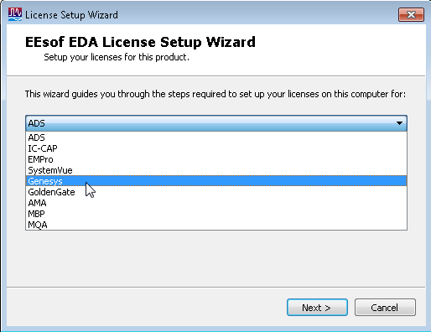

- The wizard will now prompt you for what you want to do. Depending upon your current license environment, you should select one of the following options that appear:

“I want to use a different license file”
Or
“I have a license file to install”
Or
“I want to add or replace an existing license file”

Options explained:
“I want to use a different license file” is usually seen when an earlier version license file is installed
“I have a license file to install” is usually seen when a brand new license file is setup (and no previous version license is detected)
“I want to add or replace an existing license file” is usually seen when a license file for your Agilent EEsof application is installed and you are adding or removing licensed features
- The wizard will now prompt you to enter the path and name of the v3.0 license file you wish to install. You may type the path in directory or use the Add… Clear buttons to facilitate entry of this path.
- After step 5, the license wizard should complete

- Configuring the GENESYS 2010.05 client

- In the file system, navigate to the applicable folder,

64 bit systems: C:\Program Files (x86)\GENESYS2010.05\License
32 bit systems: C:\Program Files\GENESYS2010.05\license

Remove or save to a different folder any .lic files.
- Launch GENESYS 2010.05. If GENESYS 2010.05 starts, you have completed the license setup.
- If GENESYS 2010.05 does not launch, the GENESYS license authorization window will appear. Select Purchase Software option and press Next.

- In the next window, enter the following and then hit Finish,

Current License Path: enter @<local-machine-name> for example, @xmrubin where xmrubin is the local machine.

Current Bundle Selection: Select bundles in new license file. Be careful to ensure that any “grayed out” bundles that appear on the right side of the bundle selector be removed.

Upon completing above steps, GENESYS 2010.05 should now run.

